21BDS0340

Abhinav Dinesh Srivatsa

Operating Systems Lab

Assignment – V

**Question 1**

Program: FIFO

#include <stdio.h>

#include <stdlib.h>

void fifoPageReplacement(int pages[], int numPages, int numFrames)

{

int frame[numFrames];

int i, j;

int pageFaults = 0;

int currentIndex = 0;

int exists = 0;

for (i = 0; i < numFrames; i++)

{

frame[i] = -1;

}

for (i = 0; i < numPages; i++)

{

exists = 0;

for (j = 0; j < numFrames; j++)

{

if (frame[j] == pages[i])

{

exists = 1;

break;

}

}

if (exists == 0)

{

frame[currentIndex] = pages[i];

currentIndex = (currentIndex + 1) % numFrames;

pageFaults++;

}

printf("\nPage %d: ", pages[i]);

for (j = 0; j < numFrames; j++)

{

printf("%d ", frame[j]);

}

}

printf("\n\nTotal Page Faults: %d\n", pageFaults);

}

int main()

{

int numPages, numFrames, i;

printf("Enter the number of pages: ");

scanf("%d", &numPages);

printf("Enter the number of frames: ");

scanf("%d", &numFrames);

int pages[numPages];

printf("Enter the page sequence:\n");

for (i = 0; i < numPages; i++)

{

printf("Page %d: ", i + 1);

scanf("%d", &pages[i]);

}

printf("\nFIFO Page Replacement Algorithm:\n");

fifoPageReplacement(pages, numPages, numFrames);

return 0;

}

Output:

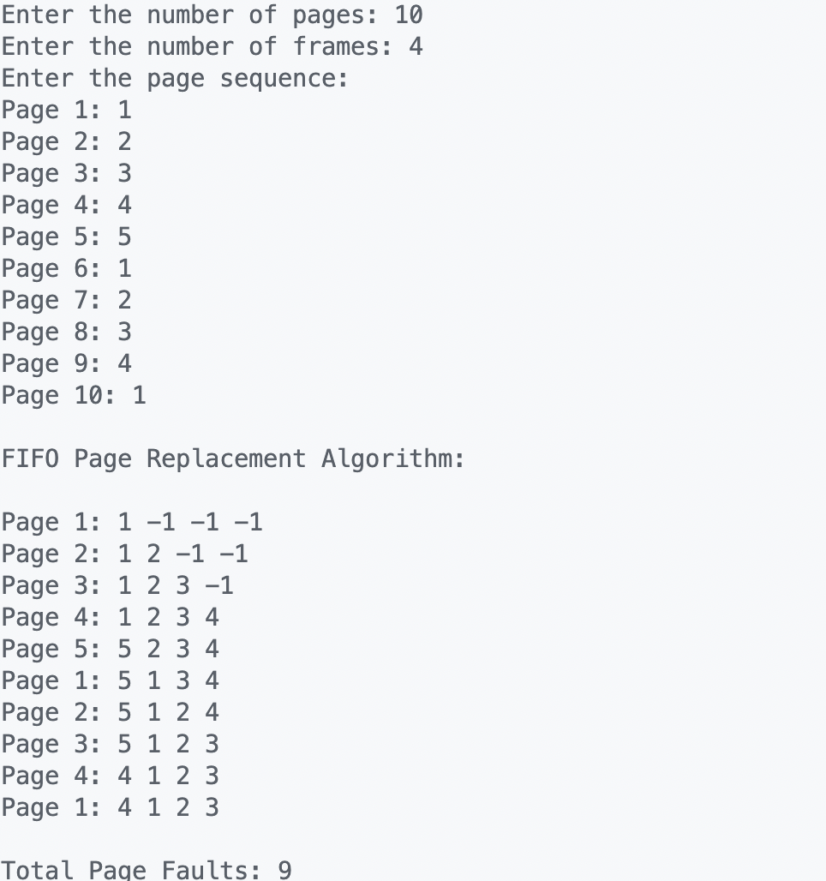

Program: LRU

#include <stdio.h>

#include <stdlib.h>

void lruPageReplacement(int pages[], int numPages, int numFrames)

{

int frame[numFrames];

int i, j, k;

int pageFaults = 0;

int currentIndex = 0;

int exists = 0;

int *counters = (int *)malloc(numFrames * sizeof(int));

for (i = 0; i < numFrames; i++)

{

frame[i] = -1;

counters[i] = 0;

}

for (i = 0; i < numPages; i++)

{

exists = 0;

for (j = 0; j < numFrames; j++)

{

if (frame[j] == pages[i])

{

exists = 1;

counters[j] = i + 1;

break;

}

}

if (exists == 0)

{

int minIndex = 0;

for (k = 1; k < numFrames; k++)

{

if (counters[k] < counters[minIndex])

{

minIndex = k;

}

}

frame[minIndex] = pages[i];

counters[minIndex] = i + 1;

pageFaults++;

}

printf("\nPage %d: ", pages[i]);

for (j = 0; j < numFrames; j++)

{

printf("%d ", frame[j]);

}

}

printf("\n\nTotal Page Faults: %d\n", pageFaults);

free(counters);

}

int main()

{

int numPages, numFrames, i;

printf("Enter the number of pages: ");

scanf("%d", &numPages);

printf("Enter the number of frames: ");

scanf("%d", &numFrames);

int pages[numPages];

printf("Enter the page sequence:\n");

for (i = 0; i < numPages; i++)

{

printf("Page %d: ", i + 1);

scanf("%d", &pages[i]);

}

printf("\nLRU Page Replacement Algorithm:\n");

lruPageReplacement(pages, numPages, numFrames);

return 0;

}

Output:

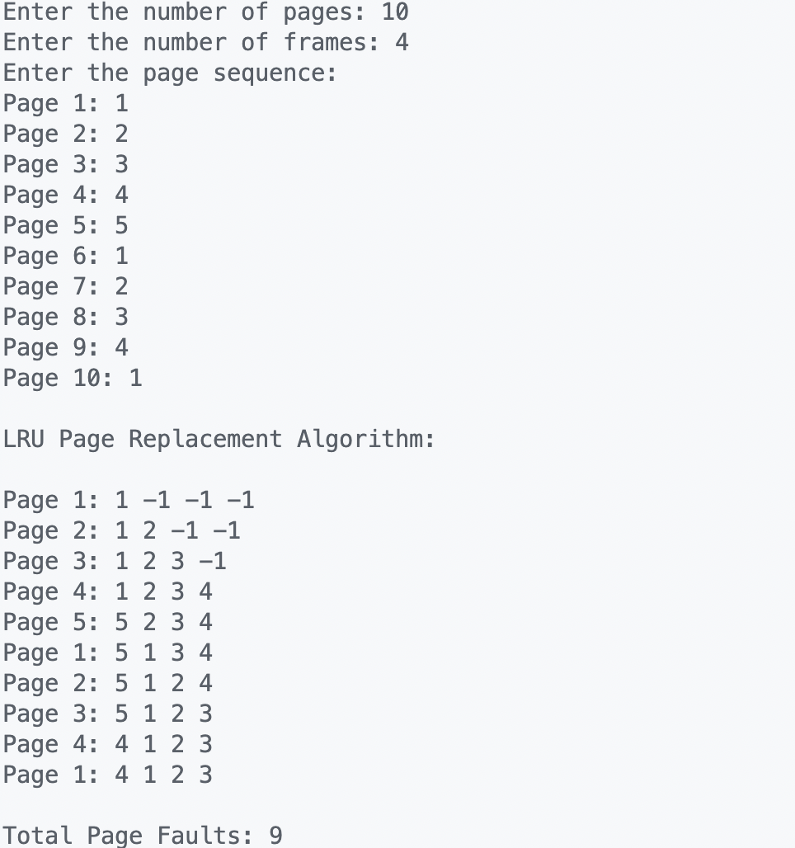

Program: Optimal

#include <stdio.h>

#include <stdlib.h>

#include <stdbool.h>

int findOptimal(int pages[], int numPages, int frame[], int numFrames, int startIndex)

{

int index = -1;

int farthest = startIndex;

for (int i = 0; i < numFrames; i++)

{

int j;

for (j = startIndex; j < numPages; j++)

{

if (frame[i] == pages[j])

{

if (j > farthest)

{

farthest = j;

index = i;

}

break;

}

}

if (j == numPages)

return i;

}

return (index == -1) ? 0 : index;

}

void optimalPageReplacement(int pages[], int numPages, int numFrames)

{

int frame[numFrames];

bool isPresent[numFrames];

int pageFaults = 0;

for (int i = 0; i < numFrames; i++)

{

frame[i] = -1;

isPresent[i] = false;

}

for (int i = 0; i < numPages; i++)

{

int j;

bool isFull = true;

for (j = 0; j < numFrames; j++)

{

if (frame[j] == pages[i])

{

isPresent[j] = true;

break;

}

}

if (j == numFrames)

{

int k;

for (k = 0; k < numFrames; k++)

{

if (!isPresent[k])

{

frame[k] = pages[i];

isPresent[k] = true;

pageFaults++;

isFull = false;

break;

}

}

if (k == numFrames)

{

int index = findOptimal(pages, numPages, frame, numFrames, i + 1);

frame[index] = pages[i];

pageFaults++;

}

}

printf("\nPage %d: ", pages[i]);

for (int k = 0; k < numFrames; k++)

{

printf("%d ", frame[k]);

}

}

printf("\n\nTotal Page Faults: %d\n", pageFaults);

}

int main()

{

int numPages, numFrames, i;

printf("Enter the number of pages: ");

scanf("%d", &numPages);

printf("Enter the number of frames: ");

scanf("%d", &numFrames);

int pages[numPages];

printf("Enter the page sequence:\n");

for (i = 0; i < numPages; i++)

{

printf("Page %d: ", i + 1);

scanf("%d", &pages[i]);

}

printf("\nOptimal Page Replacement Algorithm:\n");

optimalPageReplacement(pages, numPages, numFrames);

return 0;

}

Output:

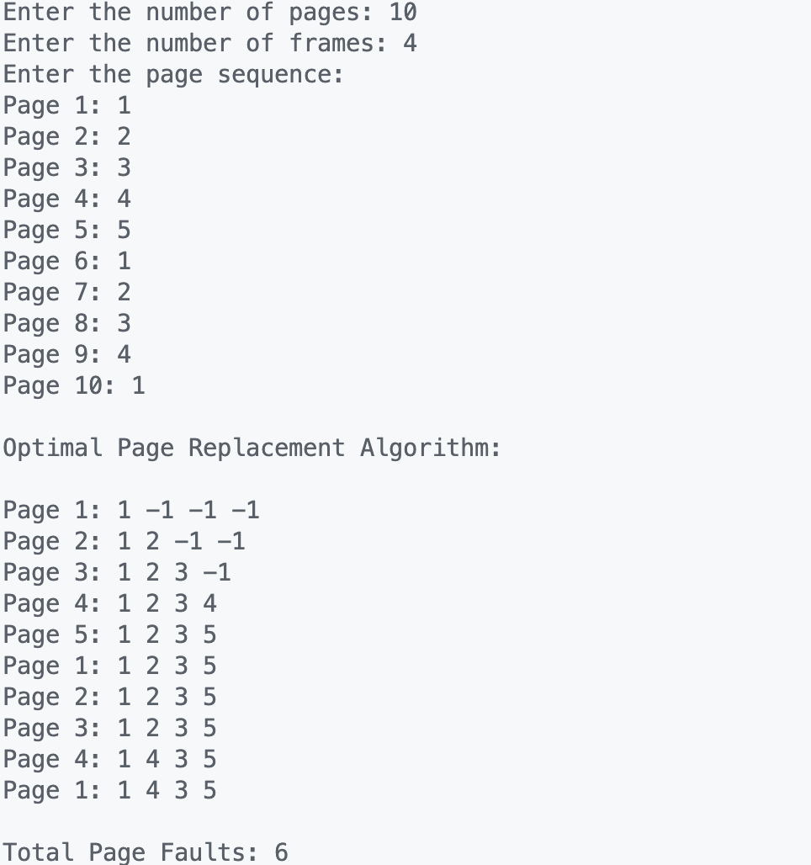

**Question 2**

Program:

#include <stdio.h>

#include <stdlib.h>

#include <fcntl.h>

#include <unistd.h>

#include <string.h>

void lockFile(const char *filename)

{

int fileDescriptor = open(filename, O_WRONLY);

if (fileDescriptor == -1)

{

perror("Error opening file");

return;

}

struct flock fl;

memset(&fl, 0, sizeof(fl));

fl.l_type = F_WRLCK; // Write lock

fl.l_whence = SEEK_SET;

fl.l_start = 0;

fl.l_len = 0; // Lock entire file

if (fcntl(fileDescriptor, F_SETLK, &fl) == -1)

{

perror("Error locking file");

close(fileDescriptor);

return;

}

printf("File locked successfully.\n");

// Simulating a locked file by pausing execution for a few seconds

sleep(5);

fl.l_type = F_UNLCK; // Unlock

if (fcntl(fileDescriptor, F_SETLK, &fl) == -1)

{

perror("Error unlocking file");

}

else

{

printf("File unlocked successfully.\n");

}

close(fileDescriptor);

}

int main()

{

const char *filename = "test.txt";

lockFile(filename);

return 0;

}

Output:

